**DC MOTOR**

A DC motor is an electrical machine that ***converts electrical energy into mechanical energy***. In a DC motor, the input electrical energy is the direct current which is transformed into the mechanical rotation.

**What is a DC Motor?**

***A DC motor is defined as a class of electrical motors that convert direct current electrical energy into mechanical energy. Works on the principle that current carrying coil placed in a magnetic field experiences a torque.***

(Torque is the measure of the force that can cause an object to rotate about an axis. Motor converts linear force into mechanical motion)

A current-carrying conductor generates a magnetic field, when this is then placed in an external magnetic field, it will encounter a force proportional to the current in the conductor and to the strength of the external magnetic field. Practical DC Motor consists of field windings to provide the magnetic flux and armature which acts as the conductor.

**F = BIL** Newtons

Where,

‘B’ is the magnetic flux density,

‘I’ is current,

‘L’ is the conductor’s length in the magnetic field.

**Hyperlink: https://youtu.be/kYAkOjlqUDo**

**DC Motor Diagram**

DC motor basically consists of two main parts. The rotating part is called the rotor and the stationary part is also called the stator. The rotor rotates with respect to the stator.

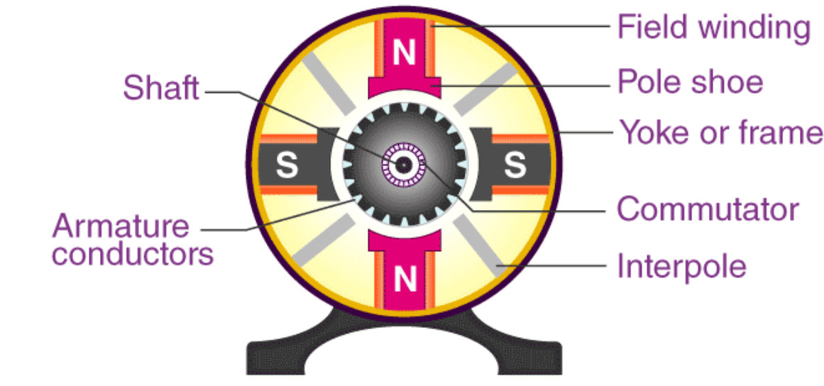 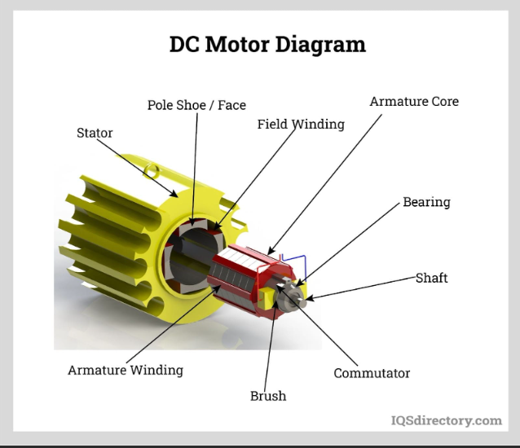

Fig 1. Different Parts of a DC Motor

A DC motor is composed of the following main parts:

**Armature or Rotor**

The armature of a DC motor is a cylinder of magnetic laminations that are insulated from one another. The armature is perpendicular to the axis of the cylinder. The armature is a rotating part that rotates on its axis and is separated from the field coil by an air gap.

**Field Coil or Stator**

A DC motor field coil is a non-moving part on which winding is wound to produce a magnetic field. This electro-magnet has a cylindrical cavity between its poles.

**Commutator**

The commutator of a DC motor is a cylindrical structure that is made of copper segments stacked together but insulated from each other using mica. The primary function of a commutator is to supply electrical current to the armature winding.

**Brushes**

The brushes of a DC motor are made with graphite and carbon structure. These brushes conduct electric current from the external circuit to the rotating commutator. The commutator and the brush unit are concerned with transmitting the power from the static electrical circuit to the mechanically rotating region or the rotor.

**DC Motor Working**

A magnetic field arises in the air gap when the field coil of the DC motor is energized. The created magnetic field is in the direction of the radii of the armature. The magnetic field enters the armature from the North pole side of the field coil and “exits” the armature from the field coil’s South pole side.

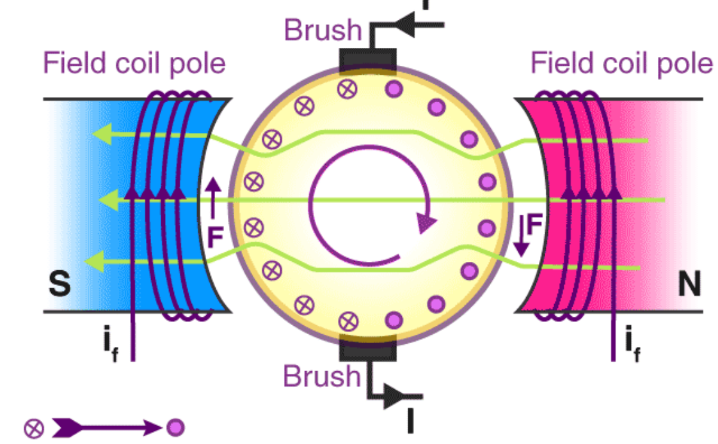

Fig 2: Production torque in DC Motor

The conductors located on the other pole are subjected to a force of the same intensity but in the opposite direction. These two opposing forces create a torque that causes the motor armature to rotate.

In DC motors, there are different popular designs of motors that are available like a brushless, permanent magnet, series, compound wound, shunt, otherwise stabilized shunt.

**Working principle of DC motor**

When kept in a magnetic field, a current-carrying conductor gains torque and develops a tendency to move. In short, when electric fields and magnetic fields interact, a mechanical force arises. This is the principle on which the DC motors work.

The rotor consists of windings, the windings being electrically associated with the commutator. The geometry of the brushes, commutator contacts, and rotor windings are such that when power is applied, the polarities of the energized winding and the stator magnets are misaligned and the rotor will turn until it is very nearly straightened with the stator’s field magnets. As the rotor reaches alignment, the brushes move to the next commutator contacts and energize the next winding. The rotation reverses the direction of current through the rotor winding, prompting a flip of the rotor’s magnetic field, driving it to keep rotating.

**Connecting DC Motor with Microcontroller**

Microcontrollers can’t drive the motors directly. So we need some kind of driver to control the speed and direction of motors. The motor drivers will act as interfacing devices between microcontrollers and motors. Motor drivers will act as current amplifiers since they take a low current control signal and provide a high current signal. This high current signal is used to drive the motors. Using L293D chip is an easy way for controlling the motor using a microcontroller. It contains two H-bridge driver circuits internally.

This chip is designed to control two motors. L293D has two sets of arrangements where 1 set has input 1, input 2, output1, output 2, with enable pin while another set has input 3, input 4, output 3, output 4 with other enable pin. Here is a video related to L293D.

Here is an example of a DC motor that is interfaced with the L293D microcontroller.

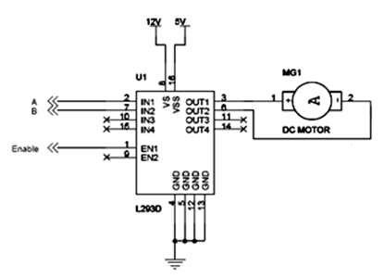

DC motor interfaced with L293D microcontroller

L293D has two sets of arrangements where one set has input 1, input 2, output 1, and output 2 and another set has input 3, input 4, output 3, and output 4, according to the above diagram,

* If pin no 2 and 7 are high then pin no 3 and 6 are also high. If enable 1 and pin number 2 are high leaving pin number 7 as low then the motor rotates in the forward direction.
* If enable 1 and pin number 7 are high leaving pin number 2 as low then the motor rotates in the reverse direction.

Today dc motors are still found in many applications as small as toys and disk drives or in large sizes to operate steel rolling mills and paper machines.

**Different Operations**

* **Make your motor spin**

**PIN DAIGRAM**

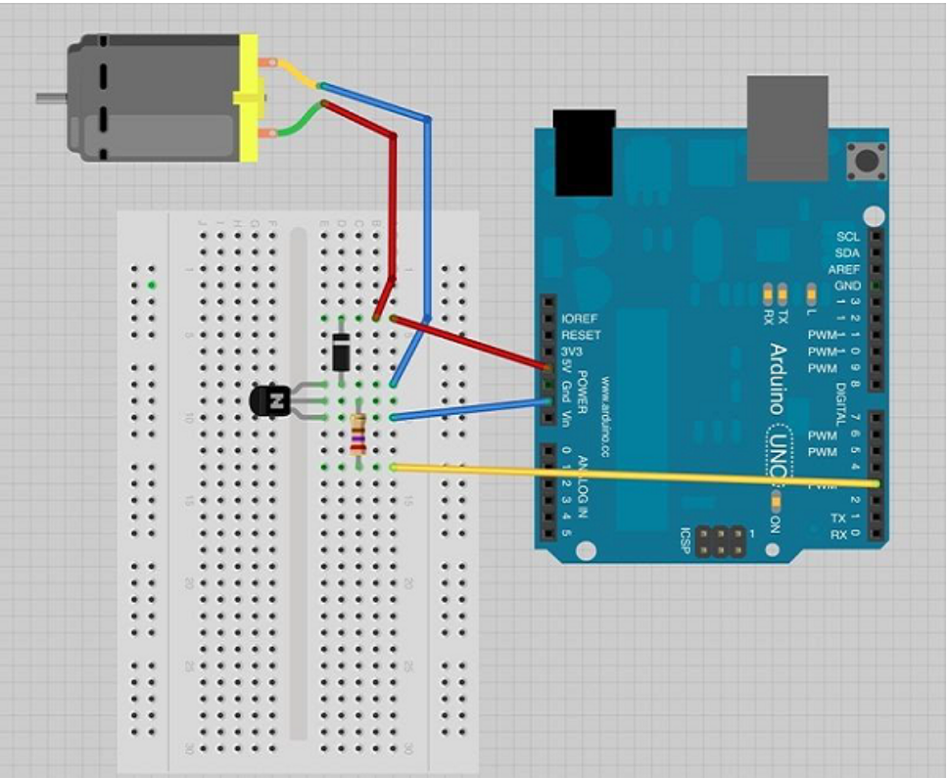

int motorPin = 3;

void setup() {

}

void loop() {

digitalWrite(motorPin, HIGH);

}

## Motor Speed Control

## Following is the schematic diagram of a DC motor, connected to the Arduino board.

## 

**int motorPin = 9;**

**void setup() {**

**pinMode(motorPin, OUTPUT);**

**Serial.begin(9600);**

**while (! Serial);**

**Serial.println("Speed 0 to 255");**

**}**

**void loop() {**

**if (Serial.available()) {**

**int speed = Serial.parseInt();**

**if (speed >= 0 && speed <= 255) {**

**analogWrite(motorPin, speed);**

**}**

**}**

**}**

## Spin Direction Control

To control the direction of the spin of DC motor, without interchanging the leads, you can use a circuit called an **H-Bridge**. An H-bridge is an electronic circuit that can drive the motor in both directions. H-bridges are used in many different applications. One of the most common application is to control motors in robots. It is called an H-bridge because it uses four transistors connected in such a way that the schematic diagram looks like an "H." The L298 can control the speed and direction of DC motors and stepper motors, and can control two motors simultaneously. Its current rating is 2A for each motor. At these currents, however, you will need to use heat sinks.

## 

## 

The above diagram shows how to connect the L298 IC to control two motors. There are three input pins for each motor, Input1 (IN1), Input2 (IN2), and Enable1 (EN1) for Motor1 and Input3, Input4, and Enable2 for Motor2.

Since we will be controlling only one motor in this example, we will connect the Arduino to IN1 (pin 5), IN2 (pin 7), and Enable1 (pin 6) of the L298 IC. Pins 5 and 7 are digital, i.e. ON or OFF inputs, while pin 6 needs a pulse-width modulated (PWM) signal to control the motor speed. The following table shows which direction the motor will turn based on the digital values of IN1 and IN2.

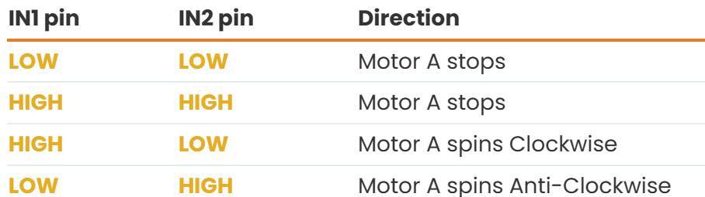

Pin IN1 of the IC L298 is connected to pin 8 of Arduino while IN2 is connected to pin 9. These two digital pins of Arduino control the direction of the motor. The EN A pin of IC is connected to the PWM pin 2 of Arduino. This will control the speed of the motor. To set the values of Arduino pins 8 and 9, we have used the digitalWrite() function, and to set the value of pin 2,

const int pwm = 2 ; //initializing pin 2 as pwm

const int in_1 = 8 ;

const int in_2 = 9 ;

//For providing logic to L298 IC to choose the direction of the DC motor

void setup() {

pinMode(pwm,OUTPUT) ; //we have to set PWM pin as output

pinMode(in_1,OUTPUT) ; //Logic pins are also set as output

pinMode(in_2,OUTPUT) ;

}

void loop() {

//For Clock wise motion , in_1 = High , in_2 = Low

digitalWrite(in_1,HIGH) ;

digitalWrite(in_2,LOW) ;

analogWrite(pwm,255) ;

/* setting pwm of the motor to 255 we can change the speed of rotation

by changing pwm input but we are only using arduino so we are using highest

value to driver the motor */

//Clockwise for 3 secs

delay(3000) ;

//For brake

digitalWrite(in_1,HIGH) ;

digitalWrite(in_2,HIGH) ;

delay(1000) ;

//For Anti Clock-wise motion - IN_1 = LOW , IN_2 = HIGH

digitalWrite(in_1,LOW) ;

digitalWrite(in_2,HIGH) ;

delay(3000) ;

//For brake

digitalWrite(in_1,HIGH) ;

digitalWrite(in_2,HIGH) ;

delay(1000) ;

}

**HOW TO CONTROL MOTOR SPEED WITH PWM**

The speed of a DC motor is directly proportional to the supply voltage. A simple way to control the speed of a DC motor is to regulate the supply voltage with pulse width modulation (PWM).

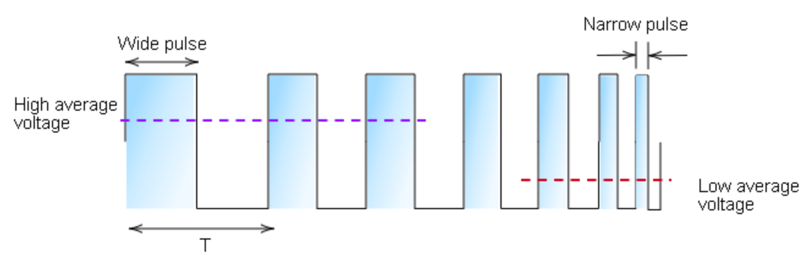

Pulse Width Modulation (PWM)

The basic idea behind PWM is that it switches the supply voltage ON and OFF very quickly. By adjusting the length of the ON/OFF pulses, we can set the voltage to anywhere between 0V and the maximum voltage. Use this PWM signal to power the motor directly.

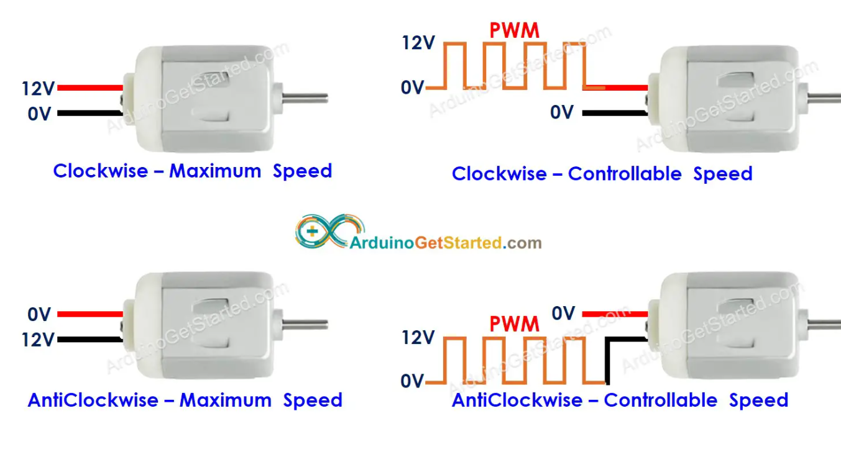

### H-BRIDGE MOTOR DRIVER

A typical DC motor has two connecting leads – one for the negative terminal and the other for the positive terminal. If you reverse these terminals (changing the polarity), the motor will spin in the opposite direction. Of course, there are better ways of controlling the direction of the DC motor without constantly changing the terminals.The H-Bridge circuit derives its name from the four transistors that look like an “H.” The H-bridge circuit achieves motor control in both directions by using different combinations of the switches (S1-S4). In a real-life scenario, we use transistors instead of basic switches.

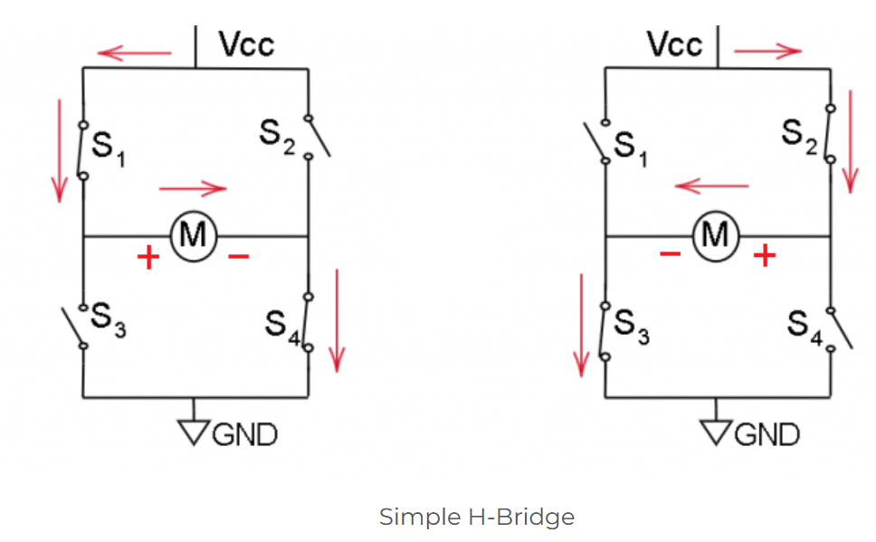

The working principle of this circuit is simple. We have four switches, S1-S4. If we open S2 and S3 and close S1 and S4, the current flows clockwise from VCC to the Ground. Now, to reverse the polarity of the motor, we open S1 and S4 and close S2 and S3. Now, the DC motor runs in the opposite direction.

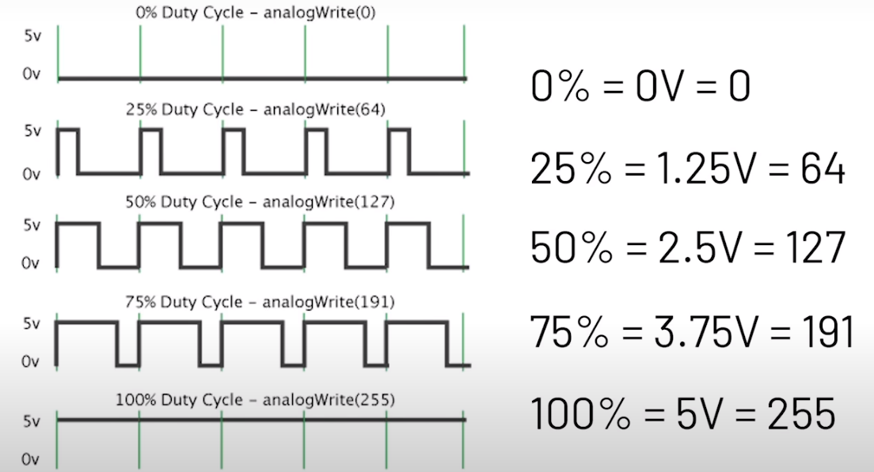

[Control DC Motors with Arduino: Wiring & Code Examples (racheldebarros.com)](https://racheldebarros.com/arduino-motor-control-with-wiring-and-code-examples/)

[L298N Motor Driver - Arduino Interface, How It Works, Codes, Schematics (howtomechatronics.com)](https://howtomechatronics.com/tutorials/arduino/arduino-dc-motor-control-tutorial-l298n-pwm-h-bridge/)